Minutes of South London Theatre Executive Committee meeting

29 May 2025, (via Zoom)

Attendees:
Gareth Milton (GM), Commercial Director, Chair
Chris Bennett (ChB), House Team
Jenny Bennett (JB), Wardrobe Team
Anne Crane (AC), Building Team
Lorna Felix (LF), Youth Team
Simon Gleisner (SG),Theatre Director
Guy Jones (GJ), Membership and Brand Team
Jess Osorio (JO) Wardrobe Team
Alistair Simpson (AS), Backstage & Technical Team
Sarah Farage (SF), Minutes

1. Welcome & Apologies
Apologies were received from Caroline Beckett (CaB), Publicity, Stephen Hayward (SH), Theatre Committee, Lisa Thomas (LT), Theatre Committee, John Winters (JW), Building Team, Noah Wright (NW), Building Team.

2. Approval of Minutes
The minutes were approved as an accurate record of the meeting.

3. Matters Arising

Cans issues - It was noted that there had been mixed experiences with the cans during the last two shows, and it was still unclear what the root cause of the issue was. AS has labelled pairs of units/headsets and the Front of House team will document any issues, noting which units/headsets were involved, during the run of Romeo &Juliet.

Action
- CB to ask Front of House volunteers to record cans issues during Romeo & Juliet.

EDI template - Some teams have completed the template, and others have discussed but not yet added their points to the document. Next steps will be discussed at the upcoming Board meeting.

Actions
- Teams to complete template asap if not already done so.
- GM to check if Bex Law has sent a list of audiences for consultation to Marysia Skwarka.

Risks - Some teams have added their risks to the report. It was noted that Backstage & Technical have a significant number of risks, and AS has a spreadsheet of these that he will share with GM. The next steps are for GM to collate the risks ahead of the next meeting where risk rating will be discussed.

Actions
- AS to send risk spreadsheet to GM to add to collated risks.
- SF to add Risk rating to agenda for next meeting.

Building projects - The team are beginning to look at solutions for the vestibule, so any additional requirements need to be added asap.

Action
- Teams to add any remaining requirements for vestibule asap.
- GM to check if Bar Damp has been added to Mini Building Projects List.

Wardrobe spend - Agreement was given for costume purchase. The Wardrobe Team are now waiting for confirmation, as the owner may have found an alternative purchaser who will take the whole collection.

New report template - The template has been used for this meeting and seems to be working well.

4. Health & Safety

AS presented the approach to developing a safety culture at SLT. In general everyone involved in productions is careful to ensure the safety of themselves and others, but there have been a number of safety incidents in the last few months. Incidents have related to a range of issues, and there is a need to move towards a better culture of safety.

The new approach has been developed by AS and the Building Team. It includes a move away from having a single person responsible for safety and developing a shared understanding and responsibility for risk management across all involved in a production. The aim is to make it easy to run a safe production, whilst maintaining flexibility to innovate (using a "yes, and..." approach).

Key elements of the plan are:
- General Technical Manager (AS) to proactively work with each director to identify the risks within each production (including invisible risks).
- Creation of a documented safety file for each show, shared with all involved in the production.
- Theatre Committee to alert AS in advance of any likely risks when the season is being planned.
- Improved training for Stage Managers.

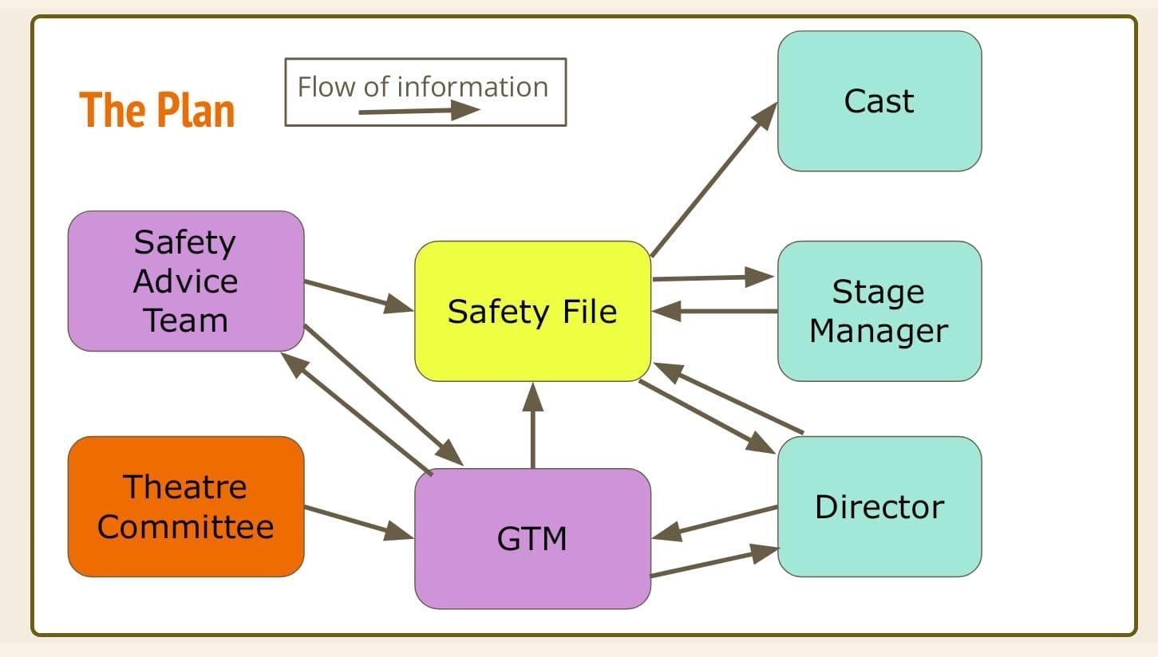

Risks relating to costumes will need to be included in the safety file. The Wardrobe Team are often not aware of the specific set design, and potential impact on costumes (such as open flames, and cast needing to walk up/down stairs in long skirts).

It is intended that the new approach be trialled with the two July shows, and will be implemented for the start of the next season (September).

It was noted that the current props policy is being reviewed, and that wardrobe needs similar consideration. There is a need to improve tracking of where props come from, and systems to ensure that they are returned to the same place. Whilst props storage is currently very well organised, it would be helpful to expand the props team.

Actions
- AS to trial new approach with upcoming shows.
- AS to discuss props policy with Carole Ironside.

5. Equality, Diversity and Inclusion (EDI) - Ticket Allocation policy

In the past SLT has offered a small number of free tickets (usually 5 per performance) to local families that would otherwise be unable to attend the theatre. This is administered by the Youth Theatre Manager who has contacts with local organisations who can signpost potential recipients. A list of recipients is sent to the Box Office team, and the tickets are booked as comps. Whilst this does have a small impact on profitability, it does contribute to EDI measures.

An alternative approach had been to offer a separate community performance with all free tickets, but take up of this has been low at times. It was noted that the fact that it is a free performance could be felt to be demeaning, and people seem less likely to attend if they have not paid for tickets.

The Executive Committee were supportive of continuing the policy of free tickets for the two family shows (Christmas and Summer). It was agreed that a percentage of tickets across the whole run of the show would allow flexibility, and ensure an appropriate balance of free/paid for tickets where shows have low capacity.

There is also an informal policy of giving a free carer ticket to those accompanying a person with a disability that requires them to be accompanied. Special rates have also been offered in the past to a local community group that attends regularly. This should be documented as part of EDI. Additionally, Youth Theatre members have been offered tickets for the Saturday Matinee of this summer's show.

It was agreed that the policy should be sent to the Board for approval as follows:
- Agreed percentage of tickets across the whole run to be offered via Youth Theatre Manager.
- Youth Theatre Manager to email Box Office with list of recipients.
- Recipients to be informed that tickets may be resold to the waiting list if they do not arrive by 5 minutes before the show.

Action
- GM/SG to ask the Board to approve the above ticketing policies.

6. Theatre and Commercial Reports

The reports from the Theatre and Commercial Teams were noted.

The Wardrobe Team are still waiting for some help in putting up a wall rack, It was agreed that a volunteer would be sought, but if no one was available within the next couple of weeks, the work could be allocated to David Clements.

The Wardrobe team are trying to locate a missing central bar that will enable them to construct a new double rail.

Actions
- GM/Wardrobe Team to seek volunteer for wall rack task.
- Wardrobe Team to post on SLT General Chat regarding missing central bar.

7. AOB
.
Following a meeting with the Trustee Board, there are plans to include the Executive Committee in a workshop on the future of the theatre with an external consultant (funded by the Architectural Heritage Fund). It is likely to be held on a Saturday in the summer.

ChB noted that there had been a discussion about Open House at the last meeting, and asked if the Executive Committee felt that it would be possible to conduct tours, given that there will be a get out/get in, with seats needing to be moved into the foyer, on that day. It was agreed that the tours should start later than usual (2pm), allowing time to ensure that the seats had been cleared from the foyer. It was hoped that the bar would be open, and it may also be possible to sell tickets and ice cream as well as the usual merchandise on the day.

Actions
- GM to circulate potential dates for workshop.
- ChB to go ahead with plans for SLT to participate in Open House on 21 September.

8. Next meeting

Monday 30 June 2025, 20.00, Kit Room, SLT

